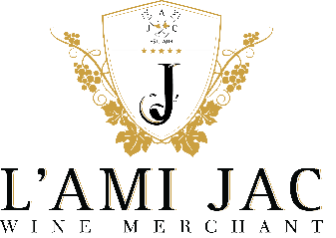
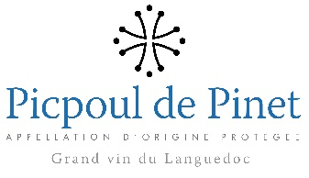
CHATEAU DE PINET 2016
PICPOUL DE PINET

Passed from father to son for 250 years, the estate is now managed by Simone ARNAUD GAUJAL and daughter Anne-Virginie, seeking the alliance of know-how and modernity. Most of their wines are characterized by low yields making it possible to obtain better concentration and an aromatic richness taking the time to develop.
In close reach to the Mediterranean Sea, Domaine Gaujal de Saint Bon is a small operation run with extreme care by the mother-daughter team of Simone and Virginie Gaujal. They are proud upholders of the Picpoul tradition (the name derived from the French 'Picque', meaning sharp, and 'poul', meaning lip, translating as 'lip stinger'), and strive to make the truest and most expressive variety in the Languedoc region.
TERROIR WINEMAKING
Seashell limestone soils Cold settling before fermentation.
Both yeast and malolactic fermentation
GRAPE VARIETY ALCOHOL
100% Piquepoul 13.5%
SERVICE TEMPERATURE HOLDING AND PRESERVATION
8°C - 10°C within 10 Years

TASTING NOTES
Delicate and fresh in the mouth it has an excellent acid/structure balance. It is a fresh, dry white wine with subtle lemony overtones and elegance.
FOOD PAIRING
Great as aperitif, this wine is not only splendid with seafood and shellfish as well as other traditional Mediterranean dishes, but also with cheese and
chocolate.

